Assignment-1

input.html

<!DOCTYPE html>
<html lang="en">

<head>
<meta charset="UTF-8">
<meta name="viewport" content="width=device-width, initial-scale=1.0">
<title>HTML and CSS Learning Project</title>
<link rel="stylesheet" href="styles.css">
</head>

<body>
<header>
<h1>Welcome to PayPal</h1>
<h2>Learn HTML and CSS with this Sample Project</h2>
</header>

<main>
<section>
<h2>List Example</h2>
<ol>
<li>item1</li>
<li>item2</li>
<li>item3</li>
</ol>
<ul style="list-style-type:square;">
<!-- Add list items as needed -->
<li>item6</li>
<li>item4</li>
<li>item5</li>
</ul>
</section>

<section>
<h2>Table Example</h2>
<table border="1">
<tr>
<td>Header 1</td>
<td>Header 2</td>
</tr>
<tr>
<td>Row 1, Cell 1</td>
<td>Row 1, Cell 2</td>
</tr>
<!-- Add row and use colspan with 2 for the td below -->
<tr>
<td colspan="2">New row common with both columns</td>
</tr>
</table>
</section>

<section id="navigation">
<h2>Navigation Example</h2>
<!-- Add hyperlinks for SamplePage1 and SamplePage2 to page1.html and page2.html -->
<p>Visit <a href="page1.html">SamplePage1 </a>
or <a href="page2.html">SamplePage2</a>
</p>

</section>

<section>
<h2>Form Example</h2>
<form action="#" method="post">
<label for="name">Name:</label>
<input type="text" id="name" name="name">
<br>
<label for="email">Email:</label>
<input type="email" id="email" name="email">
<br>
<!-- Add phone number input field and label here -->
<label for="phone">Phone:</label>
<input type="tel" id="phone" name="phone">
<br><br>
<input type="submit" value="Submit">
</form>
</section>
</main>

<footer>
<p>&copy; 2024 HTML and CSS Learning Project</p>
</footer>
</body>

</html>

styles.css

/* General reset and global styles */
body {
font-family: Arial, sans-serif;
margin: 0;
padding: 0;
}
body section{
margin:20px;
}

/* Header styles */
header {
background-color: #333;
color: #fff;
text-align: center;
padding: 10px;
}

/* Aside styles */
aside {
background-color: #f0f0f0;
padding: 10px;
width: 25%;
float: right;
}

/* Main content styles */
main {
padding: 20px;
}

/* Form styles */
form {
background-color: #f0f0f0;
padding: 20px;
border-radius: 5px;
margin-bottom: 20px;
}

/* Form input styles */
input[type="text"],
input[type="email"],
input[type="tel"] {
width: calc(100%-22px);
padding: 10px;
margin: 5px 0 10px;
border: 1px solid #ccc;
border-radius: 4px;
box-sizing: border-box;
}

/* Label styles */
label {
display: block;
margin: 10px 0 5px;
}

/* Footer styles */
footer {
background-color: #333;
color: #fff;
text-align: center;
padding: 10px;
position: fixed;
width: 100%;
bottom: 0;
}

/* Enhanced Task: Input Submit Button styles */
/* Uncomment the following properties to enable the button styling */
input[type="submit"] {

background-color: #4CAF50;
color: white;
padding: 10px 20px;
border: none;
border-radius: 4px;
cursor: pointer;

}

input[type="submit"]:hover {

background-color: #45a049;

}

OUTPUT:

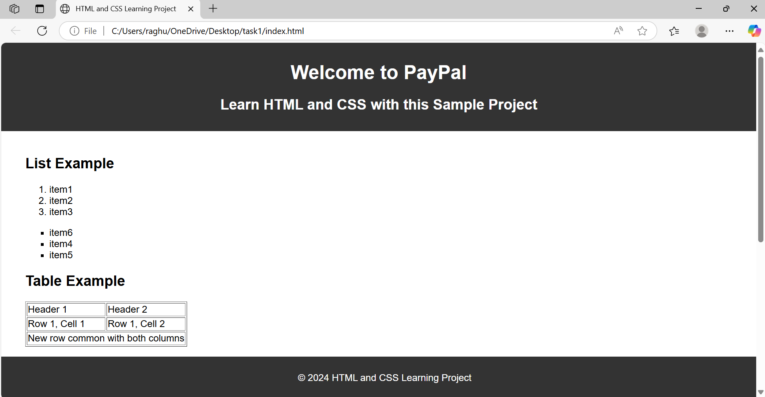
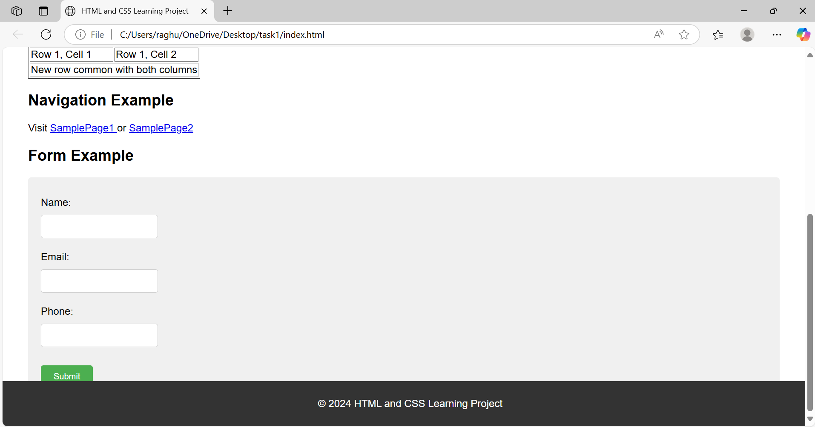

Assignment-2

Explain the following questions in two simple sentences

1.What is the use of the git add command?
The git add command is used to stage changes in your working directory before committing them.
It prepares files to be saved in your next commit to the repository.

2.Write the command to create a branch “feature-group”.
git branch feature-group
This command creates a new branch named feature-group from your current branch.

3.What is a pull request? Write the steps involved in creating a pull request.
A pull request lets you tell others about changes you’ve pushed to a GitHub branch so they can review and merge them.
Steps: Push your branch → Go to GitHub repo → Click “Compare & pull request” → Add details → Click “Create pull request”.

4.How do you add collaborators?
Go to your GitHub repository → Click Settings → Click Collaborators → Add their GitHub username.
They’ll get an invitation to access and contribute to your repository.

5.What is the command used to commit our changes in github repo?
git commit -m "commit message"
This command records the staged changes to your local Git history with a message.

6.Create a github account and repository to save all your assignment tasks. Example repository name: rg-assignments
https://github.com/amruthakatanguri/rg-assignments.git

7.Create a branch called feature-java(you can use it later to push all your java related tasks to this branch)
git branch feature-java
You can switch to this branch using git checkout feature-java to work on Java tasks separately.

8.Install IntelliJ IDE. Create a simple java project displaying “Hello World!!”and share the screenshot.
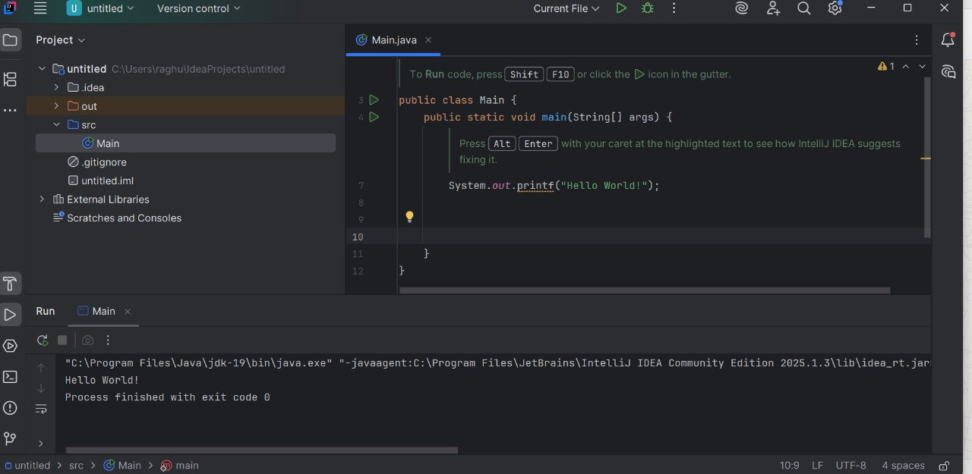

9.In IntelliJ IDE, explore the shortcut keys for the following
To run the project : Shift + F10
To select a line : Shift + Right Arrow
To comment/uncomment a line : Command + /
To delete a line : Command + Delete

